Answer 1)
Step 1 : Connect 4 routers, 4 switches and 8 PCs in the topology as shown in the Pic
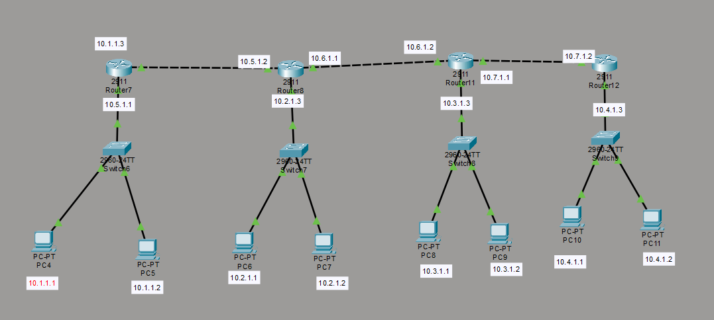
Step 2: Assign IP address to the PCs and router and gateway IPs as shown in the Pic with subnet mask 255.255.0.0
Step 3: Config the Static routing of the Router 1 as shown in the Pic by giving the network Address of all the other Networks connected with their subnet mask 255.255.0.0 with next hop 10.5.1.2
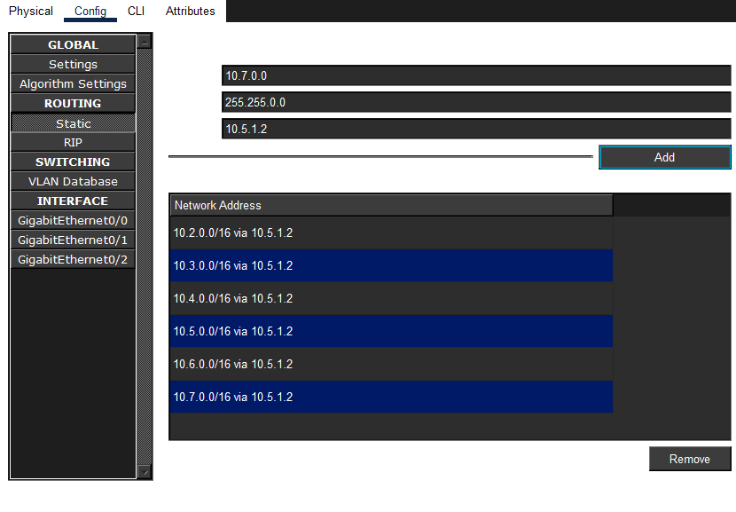
Step 4: Do the same for router 2, 3, 4 with the network address as shown in the Pic 3, 4, 5 respectively
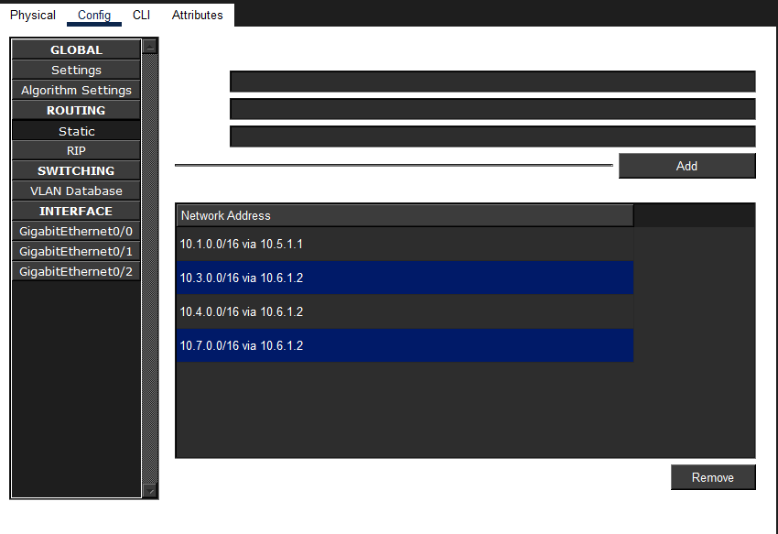
Pic 3
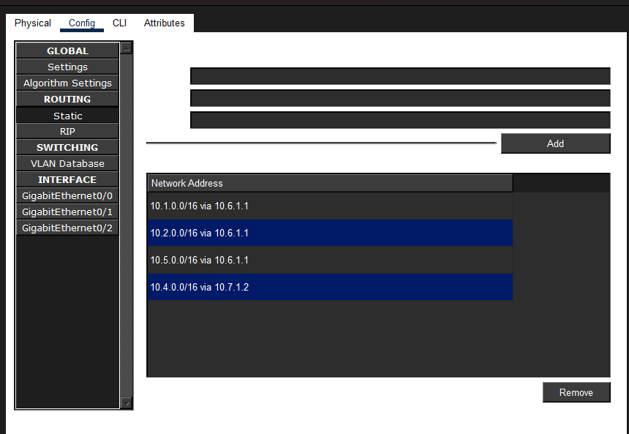
Pic 4
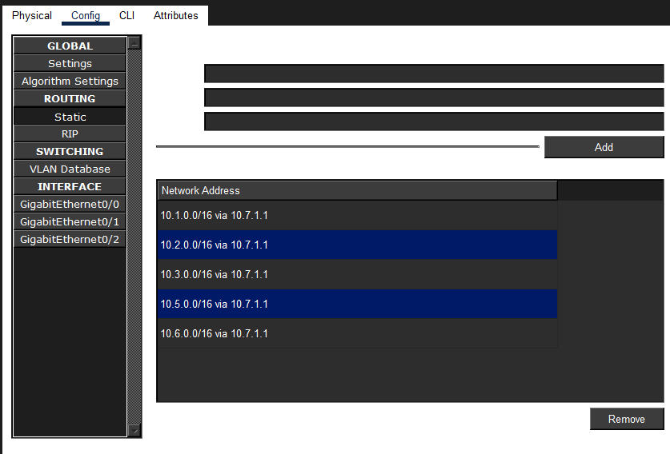
Pic 5
Step 5: Check the connections.
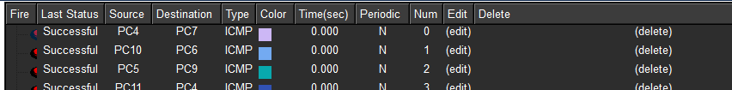

Answer 2)
Step 1: Connect 6 PCs and 1 switch in the topology as shown in the Pic
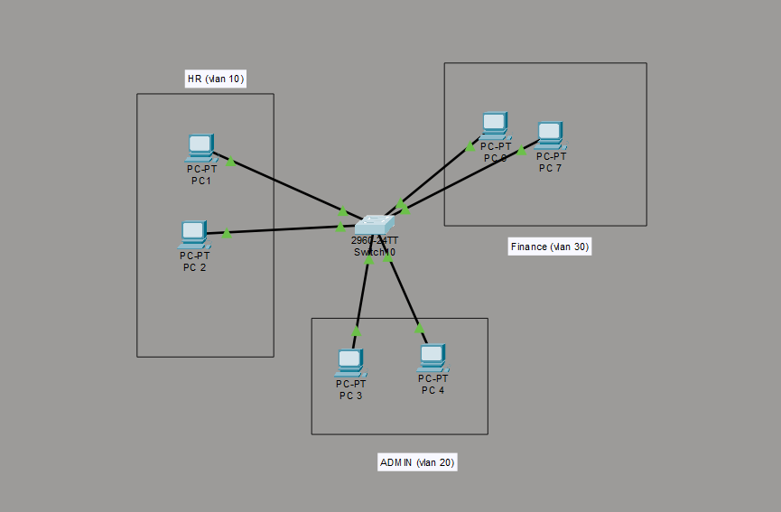
Step 2: Create vlan HR, ADMIN, and Finance with vlan IDS 10,20, and 30 respectively using the following commands in the privileged config mode
- vlan <Vlan Id>
- name <Enter Vlan Name>
for example
vlan 10
name HR

Step 3:Assign HR vlan to fa0/1, and fa0/2 , and Admin vlan to fa0/3, fa0/4, and Finance fa0/5, and fa0/6 using the following commands in privileged config
- interface <interface for ex fa0/1>
- switchport mode access
- switchport mode vlan <vlan id>
for example
- interface fa0/1
- switchport mode access
- switchport mode vlan 10
Run the following commands as shown in below Pic to assign respective vlan(s) to the respective interface
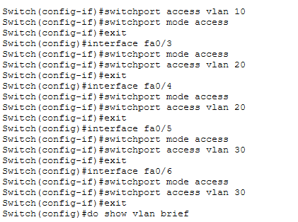
Step 4: Give fa0/24 trunk mode access
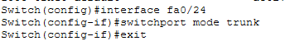

Step 5: ensure the vlan is as shown in the given fig
